Biomaterials Mechanical Testing
Jonathan Terrero (Group 3-C)
Introduction
The Mechanical Testing lab is designed to produce stress-strain curves and determine important mechanical properties. In this experiment, we use the Instron Model 5967 along with a rectangular piece of LDPE and test it at three different strain rates: 200, 400, and 600 mm/min. By applying varied strain rates, we can observe how stiffness, strength, and toughness change under faster loading conditions. LDPE is a viscoelastic material, meaning it has both elastic and viscous characteristics. This allows LDPE to adapt or remodel itself in response to applied forces, and the stress measured at each strain will show how quickly the material can adjust before it breaks. This particular polymer is expected to have a high modulus and strength while exhibiting increased ductility, making it less brittle.
Post-lab and Pre-lab Data:
Strain Rate | 200 mm/min | 400 mm/min | 600 mm/min
Thickness | 3.37 mm | 3.08 mm | 3.10 mm
Width | 12.93 mm | 12.96 mm | 13.21 mm
Cross Sectional Area | 43.57 mm² | 39.91 mm² | 40.95 mm²
Length Between Chucks (L₀) | 78.16 mm | 78.16 mm | 78.16 mm

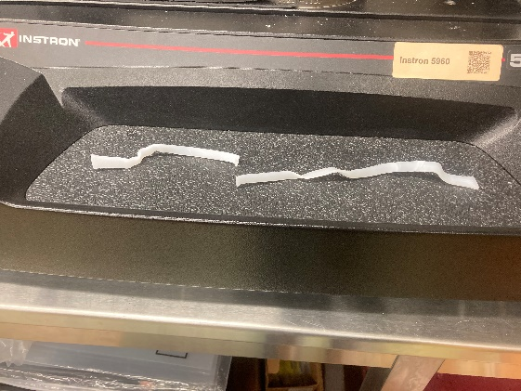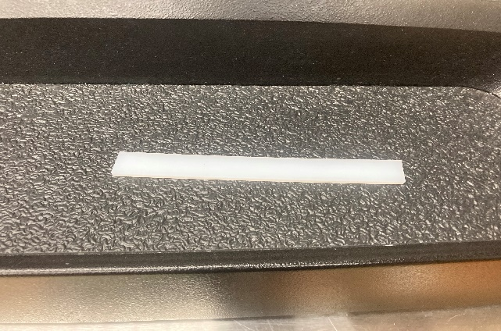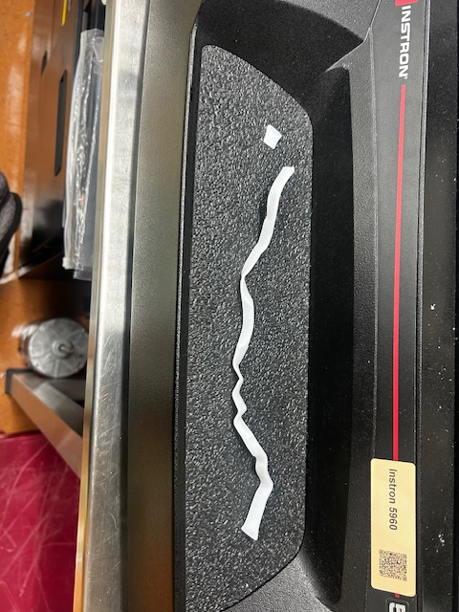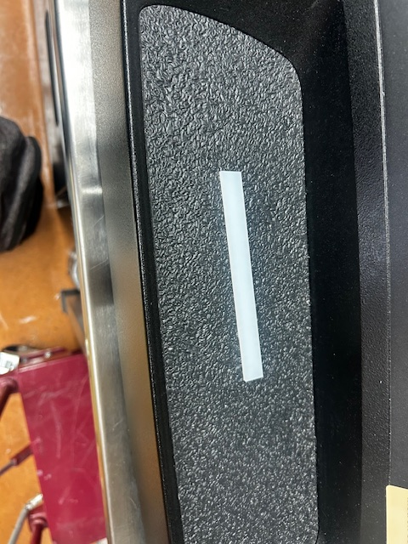

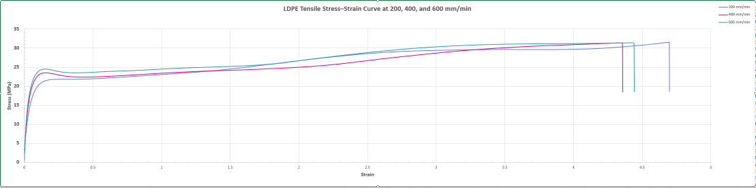
Mechanical Properties:
Metric | Value
Experimental Loading Points | 1,748
Mean Stress | 174.31 MPa
Mean Strain | 17.49
Mean Young’s Modulus | 1,053.32 MPa
Ultimate Stress | 348.19 MPa
Ultimate Strain | 34.88
Breaking Stress | 348.19 MPa
Breaking Strain | 34.88
Yield Stress (0.2% offset est.) | 0.0016 MPa
Yield Strain | 0.02
Stress and Strain Curves of Numerous Strain Rates:
Figure 7: Graph of the stresses/strains of the respective strain rates. The blue line shows the stress/strain relationship of the LDPE piece under a 200 mm/min strain rate. The red line shows the stress/strain relationship of the LDPE piece under a 400 mm/min strain rate. Lastly, the green line shows the stress/strain relationship of the LDPE piece under a 600 mm/min strain rate. It is evident from the graph that the 200 mm/min loading rate will produce a longer displacement and increased strain being resisted as the LDPE restructures itself, until failure.
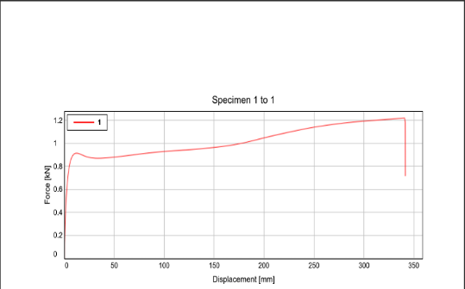
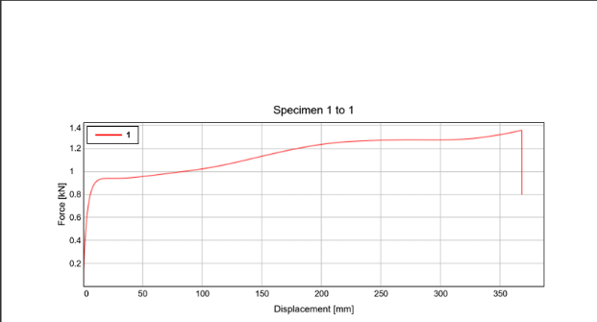
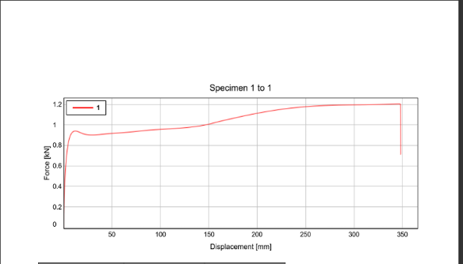
Individual Graph Overlays:

Discussion:
From the lab data, it is evident that LDPE does not exhibit particularly high stiffness compared to more rigid polymers. The material displayed elastic deformation behavior under applied forces, as clearly illustrated in Figures 2, 4, and 6. This elastic deformation shows the material’s ability to stretch and recover within certain limits without permanent damage. Moreover, LDPE demonstrated considerable ductility, which means it can undergo significant deformation before failure. Before breaking, the polymer elongated elastically without crumbling or showing brittle failure characteristics. This ductility is consistent with the polymer’s known behavior at normal room temperatures, where it acts as a tough, flexible material [Jordan et al., 2016]. However, it is important to note that LDPE’s mechanical properties are temperature dependent; it tends to become more brittle in colder environments, as discussed in studies on low-temperature mechanical properties of polyethylene blends [Salakhov et al., 2021]. Although resistance to blunt impact was not tested in this experiment, the results indicate LDPE’s toughness: it withstands significant forces and can stretch to over double its original length, as reflected in the ultimate strain and breaking strain values presented in Table 2.
The strain rates used here ranged from 200 to 600 mm/min. At the slowest strain rate of 200 mm/min, the polymer resisted failure for a much longer deformation compared to the higher rates of 400 and 600 mm/min. This aligns with expectations for a viscoelastic polymer like LDPE, which exhibits time-dependent mechanical behavior. In viscoelastic materials, faster loading usually leads to shorter deformation times before failure because the material’s internal molecular chains do not have sufficient time to rearrange or relax under rapidly applied stress [“Viscoelasticity and Mechanical Properties,” 2025]. The nonlinear stress-strain relationship observed, shown in Figure 7, is typical of viscoelastic polymers, reflecting a combination of elastic response and viscous flow due to chain sliding mechanisms. This behavior confirms that LDPE’s mechanical response varies with strain rate, affecting stiffness and toughness [Jordan et al., 2016; Materion Insights].
These findings are consistent with typical tensile testing observations where the mechanical properties of polymers like LDPE depend heavily on both loading rate and temperature [Lasky, 2024]. The polymer’s ability to extend significantly before breaking and the non-linear stress-strain behavior highlight how strain rate influences both deformation mechanisms and the timing of material failure.
Errors:
While the data generally aligned with the expected mechanical properties of LDPE, several potential experimental errors could have impacted the accuracy and reliability of the results. Measurement inaccuracies might have arisen from the calipers used to record specimen dimensions, or through human error when aligning and marking the specimen positions. These errors would affect displacement measurements and potentially skew strain rate calculations, thus influencing the resulting stress-strain curves. Given that strain rate calculations are highly dependent on precise displacement data, even minor inconsistencies can propagate into material property estimates [Lasky, 2024].
Another source of error is the possibility of imperfect specimen gripping in the Instron machine clamps. Although no visible slippage occurred (as indicated by clean fracture surfaces), small slips or incomplete fixation might have slightly altered stress distribution or led to localized stress concentrations, affecting the measured mechanical response. The setup and alignment of the specimen are critical to ensuring uniform load distribution, especially for viscoelastic materials that respond sensitively to strain rate and stress conditions [Jordan et al., 2016].
Lastly, computational errors could have resulted from data processing steps. These could include misunderstandings about the calculation formulas, rounding errors in software implementations, or data recording inaccuracies due to sensor limitations or software updates. Such errors could influence the precision of key material parameters such as modulus, ultimate strain, or toughness. A thorough verification step including repeated trials and cross-checking raw data could help mitigate these sources of error in future experiments.

